**Overview**

The Zscaler Digital Experience (ZDX) Admin Portal is an online dashboard designed to perform probing to desired Software-as-a-Service (SaaS) applications (apps) or internet-based services (e.g., OneDrive, Teams, etc.).

This guide will provide the best practice(s) on how Tier I and Tier II Technicians should utilize the dashboard to access reporting data. This can help pinpoint the source of performance issues and capture screenshots; aiding to troubleshoot and resolve or escalate the end-user’s Zscaler issue(s).

Accessing the ZDX Admin Portal

To access the ZDX Admin Portal:

1. On your CFPB device, go to [myapps.microsoft.com](https://myapps.microsoft.com/) by clicking on the link.

**Note:** Single Sign-On allows your CFPB credentials will be used on this site.

1. Scroll through the apps and find **Zscaler (ZDX SAML SSO) Admin**.

**Note:** Hover on an app and on the left-hand corner, use the **=** to reorder apps.

1. A new tab will open for the ZDX Zscaler Digital Experience console.

**Note:** Single Sign-on may ask you to log in again using Windows Hello or PIV. Inactivity in the ZDX Admin Portal will result in having to relaunch it from the My Apps dashboard. Bookmarking does not automatically sign you in.

Navigating the Performance Dashboard

The **Performance Dashboard** includes dropdown menus to filter by Department, User Groups, etc. and timeframe.

The left menu helps drill down more specifically by Application, Users, etc.

Most Impacted Applications are listed on a ribbon based on the lowest score. Each app summary shows a *ZDX Score*, *Most Impacted Location*, and *Total Users*. Scroll left to right to view more apps and click on an app box to update the dashboard graphs.

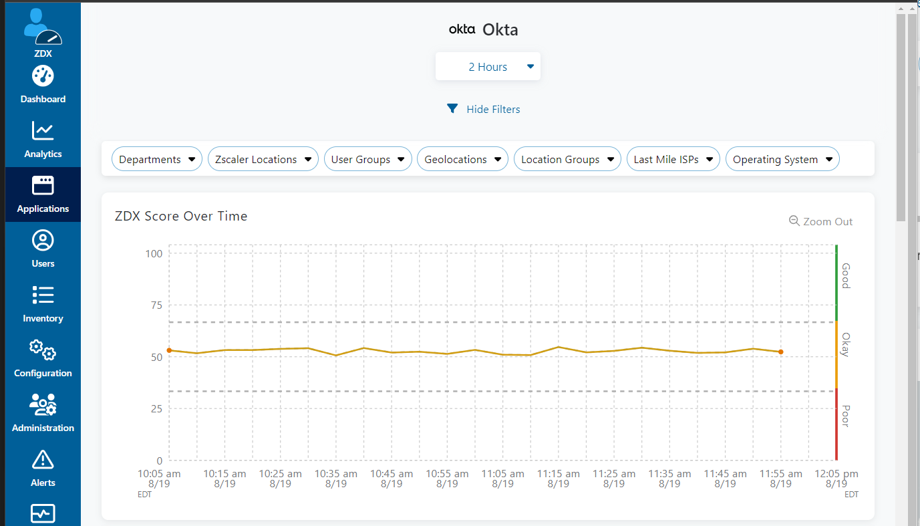Click any hyperlink in this ribbon to open app details with a deeper dive into performance and status. Details for a specific app allow you to view ZDX Score Over Time, Page Fetch Time, Regions by ZDX Score, Impact by Departments, Regions, and Zscaler locations.

**Note:** The Applications menu is selected on the left menu.

To get back to the main page, click on Dashboard on the left and select Performance Dashboard.

The Regions by ZDX Score map displays the geographic locations of all end-users accessing the selected CFPB application.

Hovering the mouse over any marked location on the map reveals the city name, ZDX Score, and Total Users. Click the Details icon (Details icon within tooltip) to view user information in the Users Overview specific to the location.

Zoom in and out of the map to better view regions of interest.

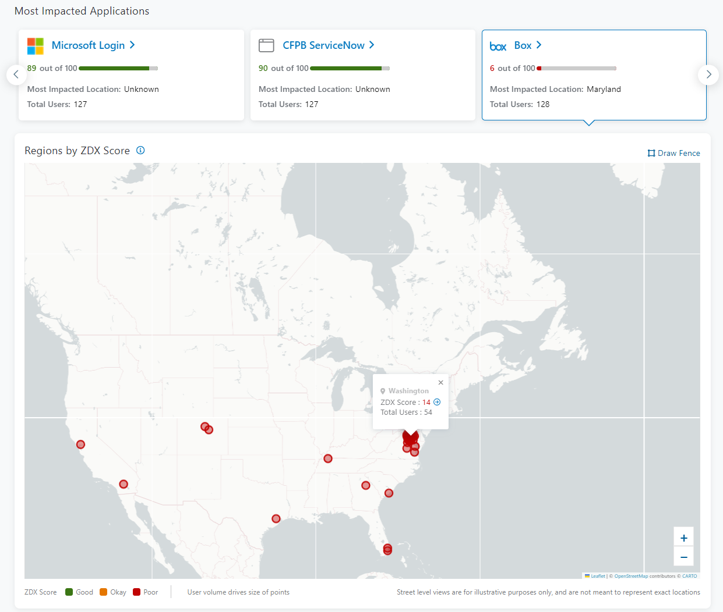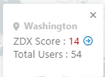



Legend

* **Good**: Indicates the score is above an acceptable threshold.
* **Okay**: Indicates the score is at an acceptable threshold.
* **Poor**: Indicates the score is below an acceptable threshold.

The ZDX Score graph shows how the ZDX Score trends over the time period selected as a line across the graph, also tracking the score of the most impacted app(s) and the impact on the overall score.

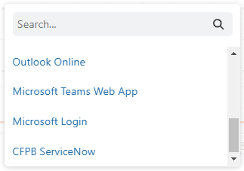

**Note:** Compare up to four additional apps by clicking Add Another Application below the graph. Use the pop-up menu to add or remove additional apps to view. The ZDX Score for the selected apps is displayed.

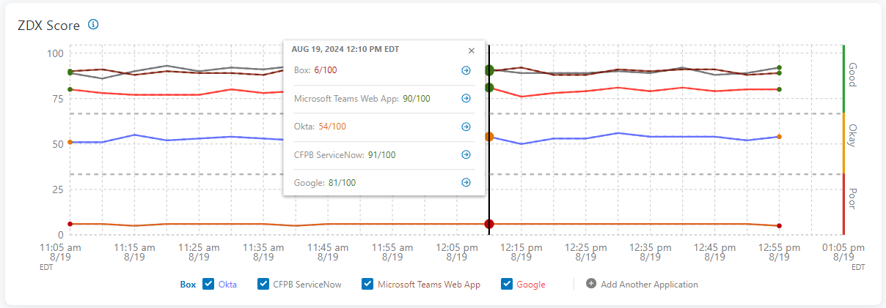Click a point in the graph to display the ZDX Score for the selected apps at that time.

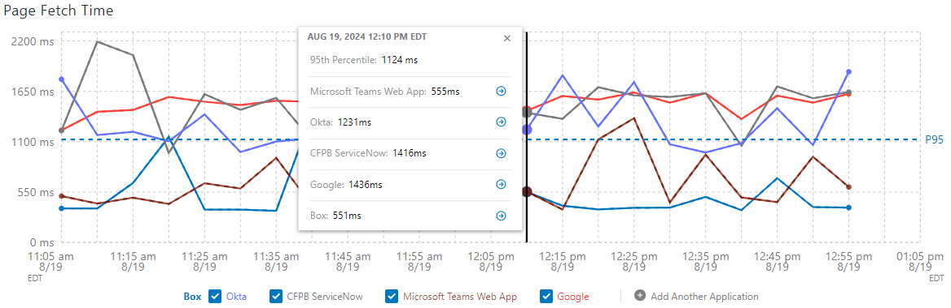App selections made in the ZDX Score populate the Page Fetch Time graph. This graph tracks how long it takes the selected app(s) to transfer the fetched page to the user during the selected time period.

Navigating the Applications Overview Dashboard

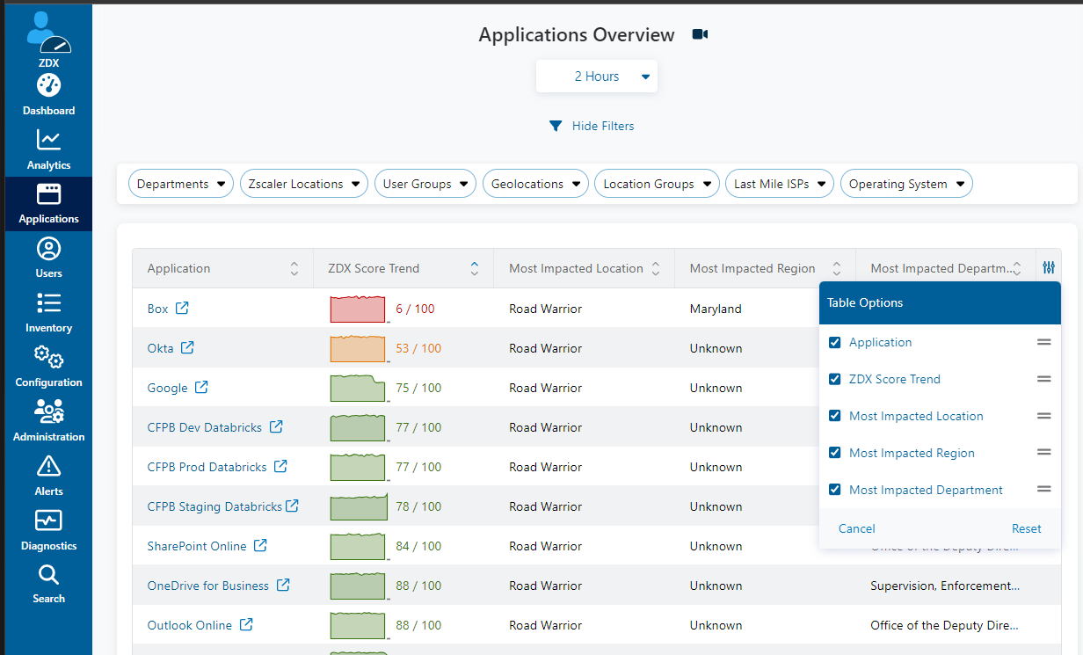The **Applications Overview Dashboard** has been configured with SaaS and CFPB specific applications. To access this dashboard, click on the Applications icon on the left menu.

The Table Options filter allows you to edit the columns used and order presented.

The Sort filter toggles the data order.

Clicking on any app name will dig deeper with more information.

Navigating the Users Overview Dashboard

The User Overview Dashboard allows you to select one or more groups, departments, applications, and users at a time to monitor reports specific metrics.

Click the Users filter.

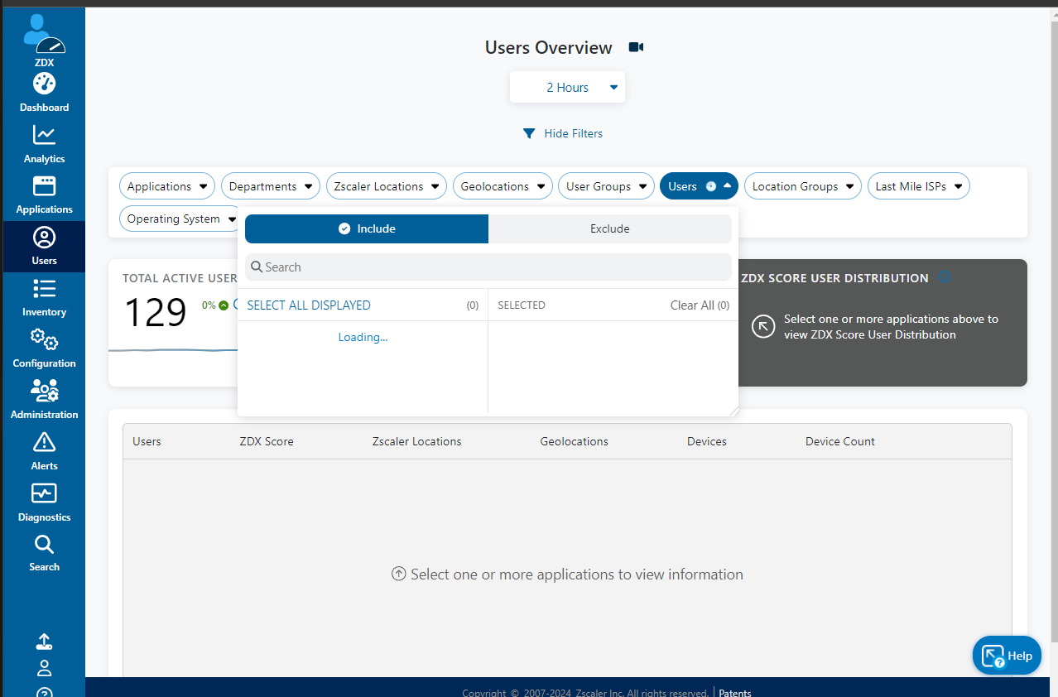

The list will populate with CFPB end-users currently on Zscaler. Select the user(s) you need to monitor.

Click **Apply**.

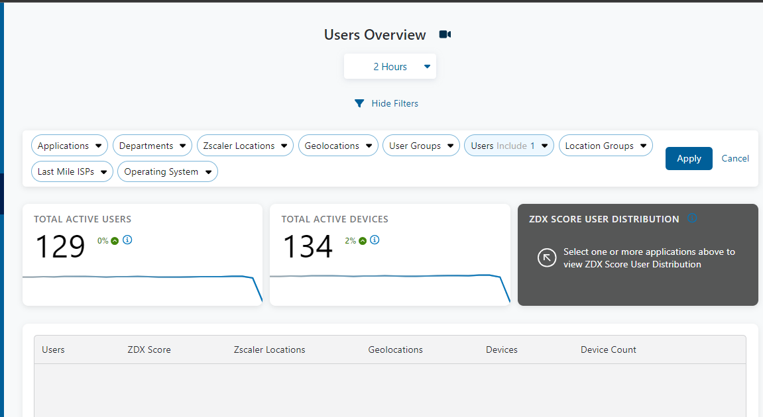

The chart will update to reflect the Total Active Users and Total Active Devices selected as it applies.

Navigating the ZDX Admin Portal

The Zscaler Digital Experience (ZDX) Admin Portal is an online dashboard designed to perform probing to desired Software-as-a-Service (SaaS) applications (apps) or internet-based services (e.g., OneDrive, Teams, etc.

Navigating the ZDX Admin Portal

The Zscaler Digital Experience (ZDX) Admin Portal is an online dashboard designed to perform probing to desired Software-as-a-Service (SaaS) applications (apps) or internet-based services (e.g., OneDrive, Teams, etc.

Navigating the ZDX Admin Portal

The Zscaler Digital Experience (ZDX) Admin Portal is an online dashboard designed to perform probing to desired Software-as-a-Service (SaaS) applications (apps) or internet-based services (e.g., OneDrive, Teams, etc.